**UK BANK CUSTOMER ANALYSIS**

**Creating Database :**

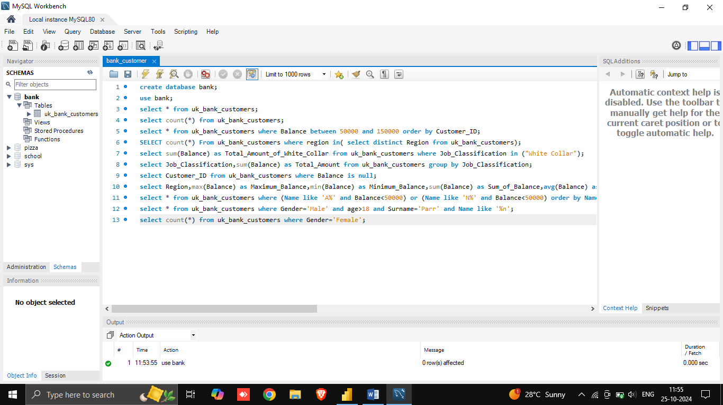

**OUTPUT:**



**Selecting all Data:**

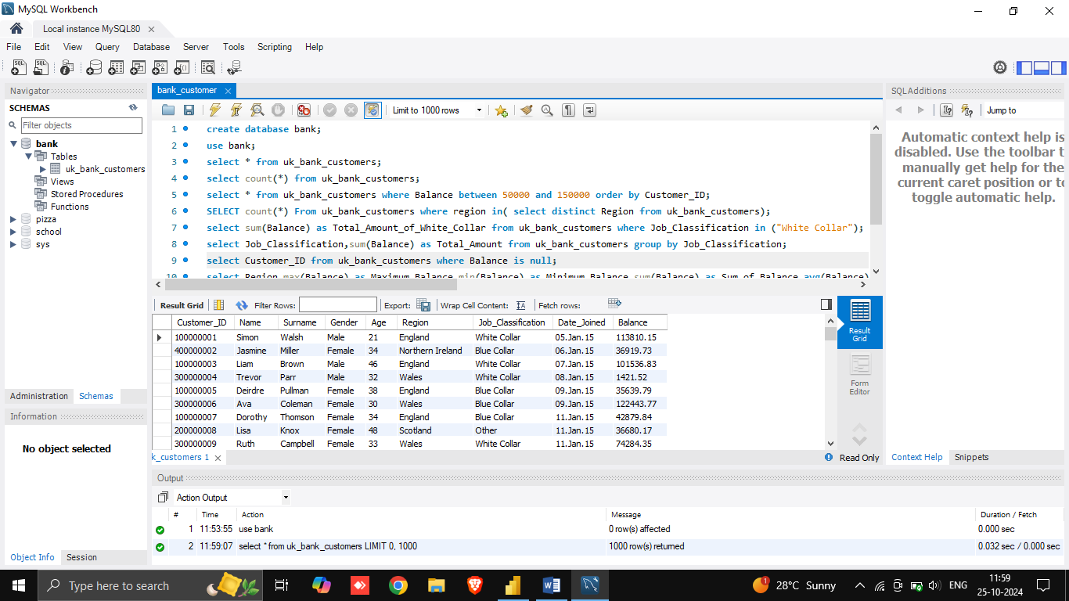

**OUTPUT:**



**Using BETWEEN Operator :**

1. Retrieve the details of all UK bank customers whose balance is between 50,000 and 150,000, ordered by their Customer ID.

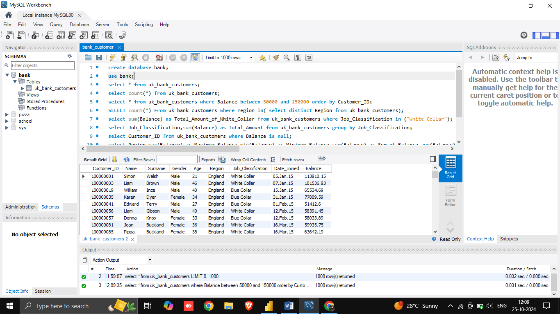

OUTPUT:



**Using GROUP BY Clause:**

2. Calculate the sum of balances for each job classification in the UK bank customers' data.

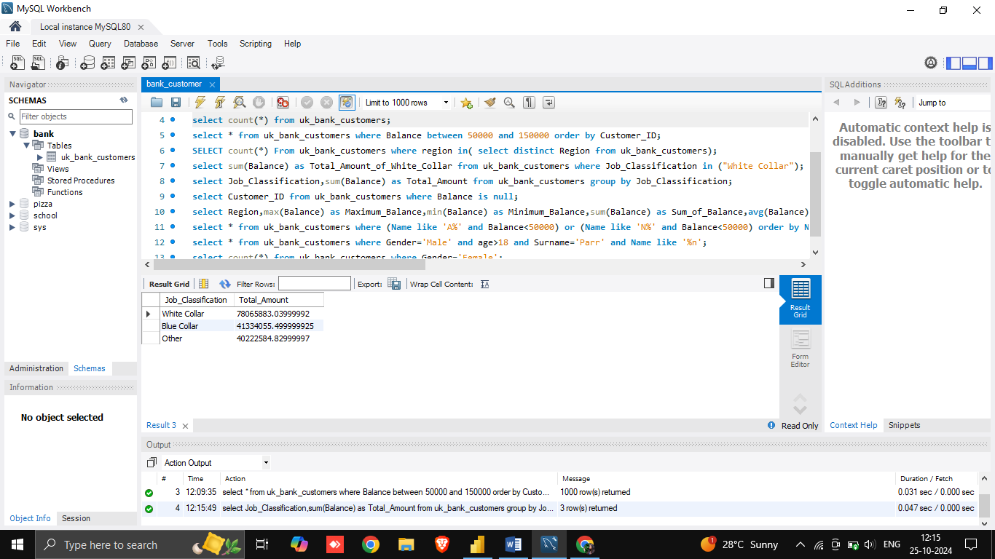

OUTPUT :



**Using Aggregate Functions :**

3. Provide a summary of customer balances for each region, including the maximum, minimum, total, average balance, and the number of customers.

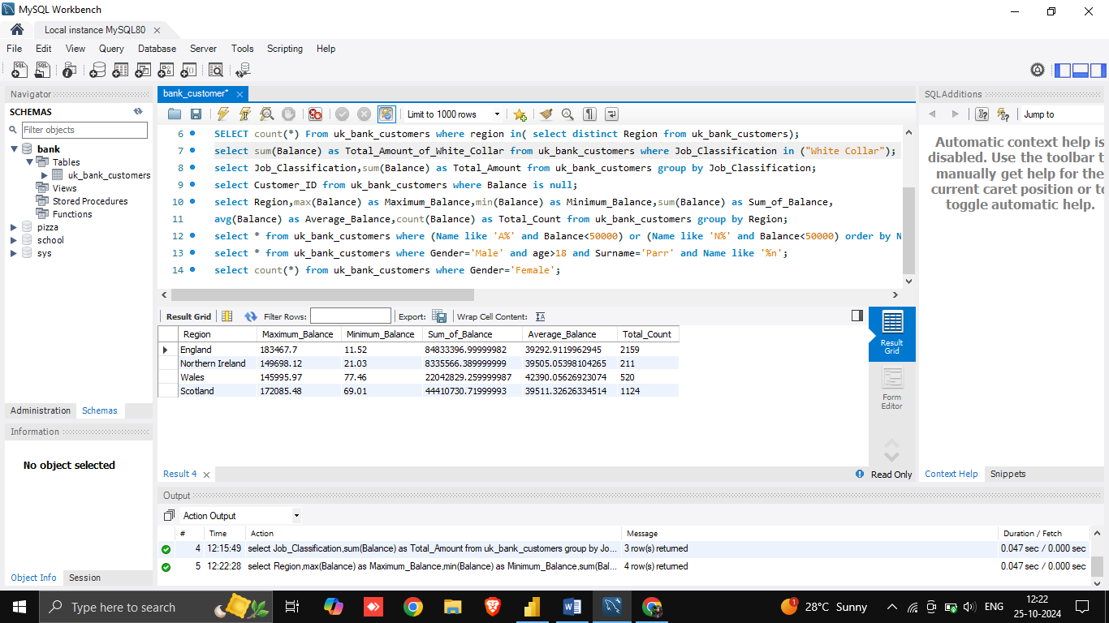

OUTPUT:



**Using LIKE Operator and ORDER BY Clause :**

4. List all customers whose names start with 'A' or 'N' and have a balance of less than 50,000, ordered by name.

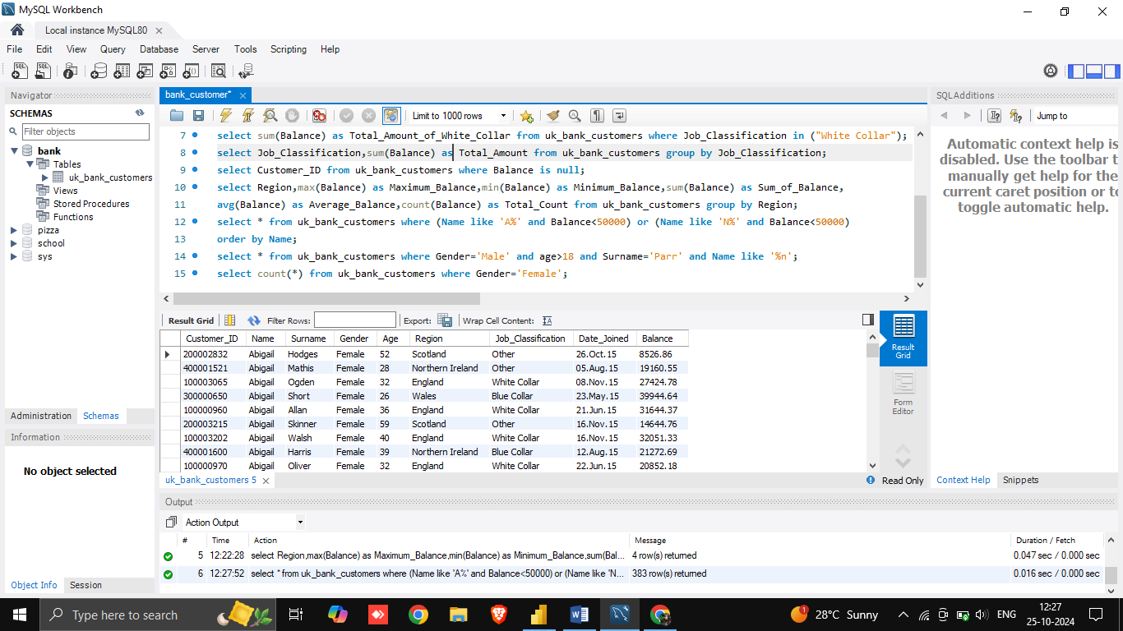

OUTPUT:



**Using AND Operator :**

5. Retrieve all information for male customers older than 18, with the surname 'Parr' and a first name ending in 'n'.

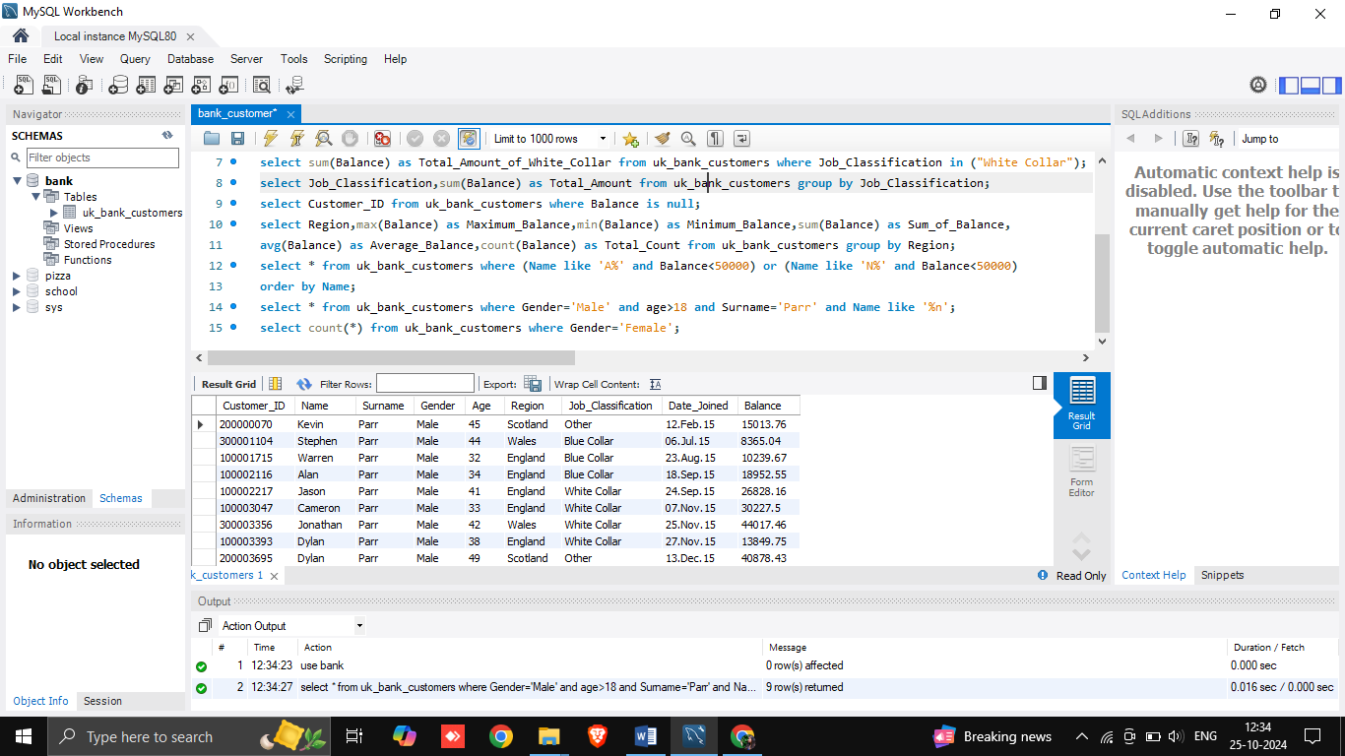

OUTPUT:

